**Project Name:** HealthCare Website

**Github Link:** https://github.com/projectsforstudents2022/HealthCare_Website.git

**Why was this project created?**

Healthcare websites will aid hospitals in managing appointments, medical records, and patient registration more effectively. It allows administrators and clinicians to view and, if necessary, adjust appointment schedules. The goal of this initiative is to computerize all information pertaining to patients and the hospital.

**What problem is it solving?**

Patients can register on this website, enter their information into the system, and schedule appointments with doctors. Our programme has the ability to automatically store each patient's and the staff's information while also providing a unique identifier for each patient. Using the ID, a user can look up a doctor's availability and a patient's information.

**Entire explanation of project**

* **PROPOSED APPROACH**

The admin module and the user module are the two modules that make up our application. The admin can modify, add, or update records using our application in addition to assisting with monthly data preview. The programme will also assist the administrator in keeping track of patient transactions and generating confirmations for those transactions. The administrator will have access to manage and update doctor-related data. Both patients and doctors have access to the user module. The Appointments can be confirmed or canceled by the doctor. Using our programme, the doctors can even add prescriptions for their patients. Patients will be able to request appointments, complete transactions for those visits, and even change or cancel their appointments with the doctors. They have access to information regarding their previous transactions. The application will be utilized by hospitals, clinics, dispensaries, and other healthcare facilities. The system's goal is to improve the number of people who can receive effective care. The management of the hospital must make significant efforts to secure the files if the hospital management system is file-based. Fire, insects, and natural disasters can all readily damage them. also be lost if data and information are lost.

* **RESULT**

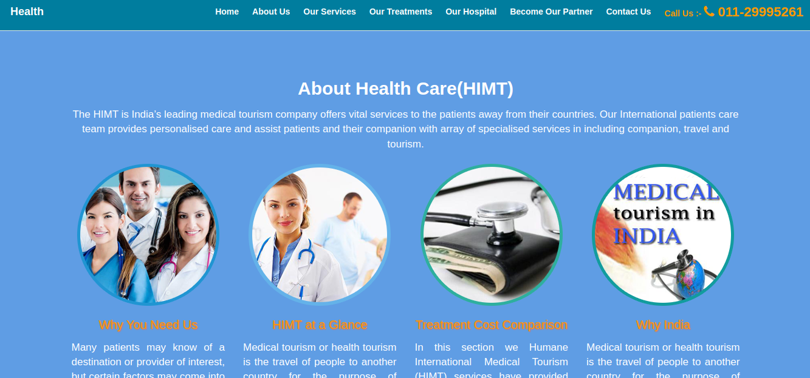

**CONCLUSION**

The project took a lot of labor and effort to finish successfully. This project experienced a number of compilation, debugging, error removal, and bug-free processes. It also added new Hospital Management System features and interactivity, making it more dependable and practical. The complete project has been created and implemented in accordance with the user's stated specifications. According to the implemented testing criteria, it is discovered to be bug-free.